Cognifyz IT Solutions pvt.ltd
Task: Predict Restaurant Ratings
HARINI R
Ref.: CTI/A1/C34761

Objective
- To predict the aggregate rating of a restaurant using regression techniques based on given features
Aim
- To build a machine learning model that accurately predicts restaurant ratings using historical data
Dataset Description
The dataset contains multiple features related to restaurants
Restaurant Information
- Restaurant ID
- Restaurant Name
- Country Code
- City
- Address
- Locality
- Locality Verbose
Location Features
- Longitude
- Latitude
Service Features
- Cuisines
- Has Table booking
- Has Online delivery
- Is delivering now
- Switch to order menu
Pricing Features
- Average Cost for two
- Currency
- Price range
Target and Feedback Features
- Aggregate rating (Target variable)
- Rating color
- Rating text
- Votes
Step 1 Model Training
Libraries Used
- Pandas for data manipulation and handling
- NumPy for numerical computations
- Matplotlib for data visualization
- Pickle for saving and loading model
- RandomForestRegressor for training regression model
- Evaluation metrics R2 Score and Mean Squared Error
Procedure
Data Loading
- Dataset is loaded using Pandas
- Dataset size is checked for reference
Data Preprocessing
- Irrelevant columns are removed to improve accuracy and reduce training time
- Categorical values are converted into numerical format

Data Visualization
- Histograms and plots are used to understand data distribution
- Rating patterns of restaurants are analyzed
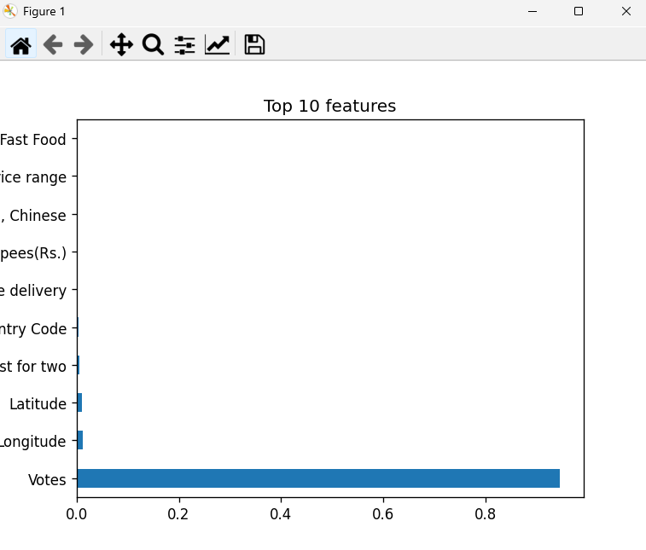
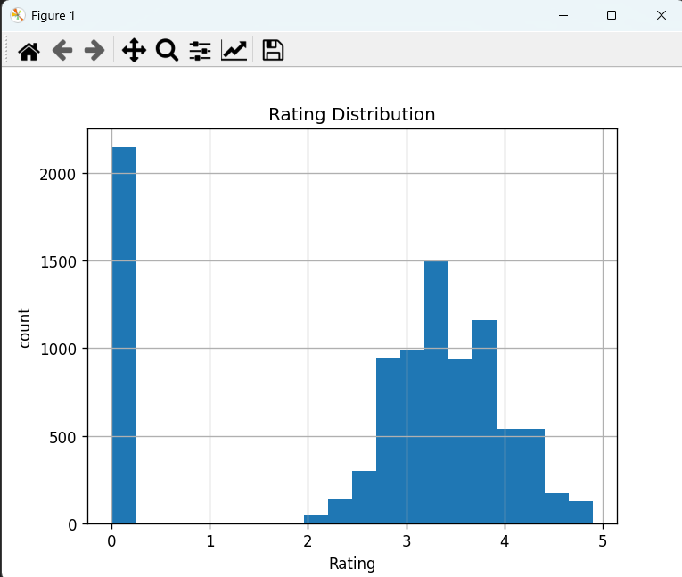

Feature Selection
- Aggregate rating is separated as the target variable
- Important features are selected for training
Feature Importance Results
- Votes 0.945680
- Longitude 0.012233
- Latitude 0.009974
- Average Cost for two 0.005027
- Country Code 0.004094
- Has Online delivery 0.000875
- Currency Indian Rupees Rs 0.000700
- Cuisines North Indian Chinese 0.000697
- Price range 0.000600
- Cuisines Pizza Fast Food 0.000582
Model Training
- Random Forest Regressor is used for training
- Model learns relationship between features and target rating
Model Evaluation
- Evaluated using R2 Score
- Evaluated using Mean Squared Error
Model Saving
- Model is saved using Pickle as model.pkl
- Feature columns are saved as columns.pkl

Step 2 Deployment

Streamlit Framework
- Model is deployed using Streamlit web application

User Input
- Users enter restaurant details such as votes, cost, price range, and delivery options

Prediction Output
- Model predicts restaurant rating
- Output is displayed with interpretation:
  - Excellent Restaurant
  - Good Restaurant
  - Needs Improvement

Final Outcome
- A machine learning system is built and deployed successfully
- The system predicts restaurant ratings based on user input with an interactive interface
- STREAM LIT LINK
https://cognifyz-avnz9qrc8ptjkpw6vjctj6.streamlit.app/

- GITHUB LINK
https://github.com/harini-012/Cognifyz/tree/main/task1

